ManuConnect Release - 2020.12.14
Release Date | 14 Dec 2020
Core Installer | 7.0.01214.701
Installer Suite | 7.0.01214.1049

Overview
Today's release includes several PAD and Transaction Register changes.
IMPORTANT!
CWI NuGet packages have been updated in today's code drop. This update is intended to roll back the recent change that was delivered on 2020.12.07. The rolling back enables Manulife's own applications to work until their build process is modified.
Change that is reverted: [CDTASMU-10532] The Addition of Client Maintenance Member Events Causes an Issue for Client Life Events

VO API Fixes
Feature | Client No. | Category | Summary | Release Notes
VO-2419 | - | Services | UpdateBenefit endpoint throws exception | Fixed an issue in Member Benefits > Update endpoint. It got accidentally broken on adding caching of PlanInformation

Defects Addressed
Defect | Client No. | Category | Summary | Release Notes
MLU-844 | 2386 | Admin GUI | [CDTASME-2386] PAD reports - Changes to PAD_ExclusionReport | - Default the Location Bank Account Usage drop list to "Automatic Withdrawal".  - Default the Member Bank Account Usage drop list to "Health/Dental claims".  - The bill run day must be at least 5 days after the pad pull date. The PAD withdraw date/day is compared against the Bill Run Day. There should be a 5-day difference. If Bill Run Day is NOT at least 5 days greater than PAD Withdraw Date/Day, then display an error message:  "PAD Withdraw Day should be at least 5 days earlier than Bill Run Day"
MLU-843 | 2568 | Accounting | [CDTASME-2568] PAD Payment Batch item details not matching with VO4 current behavior | In cases where the insured and ASO balances are in opposite sign, the PAD job is required to produce additional transactions in order to bring those balances down to zero.  For details please refer to the Change Request document.  Notes:  - The transaction that is used to reduce a debit balance is a "Negative Deposit", which is SubCategoryId 10002  - The transaction that is used to reduce a credit balance is a "Credit Adjustment", which is SubCategoryId 5  Please advise us if these transaction types (SubCateogryId) need to be changed.
MLU-803 | 2574 | Accounting | [CDTASME-2574] Activating new locations in Transaction Register | In the Search window, there are two ways to display the search result. Use the DISPLAY ALL ACCOUNTS checkbox, as followed:  - When searching all accounts - a row will be displayed for each applicable account type (even if that account type is not yet activated). The ClientPlanBenefit records that are associated to the location will determine which account types are applicable. Selecting a row from the search result will automatically activate the account if it is not already so.  - When searching by single account (all accounts unchecked), the lowest applicable account type (MLI-billed, client-billed, ASOBAR) for the selected location is displayed. The ClientPlanBenefit records that are associated to the location will determine which account types are applicable. Selecting a row from the search result will automatically activate the account if it is not already so.  - When transferring, the location search (both all account and single location search) should perform the same account selection as above (if necessary).  - When using global search, the same behavior will also apply to locations as above.  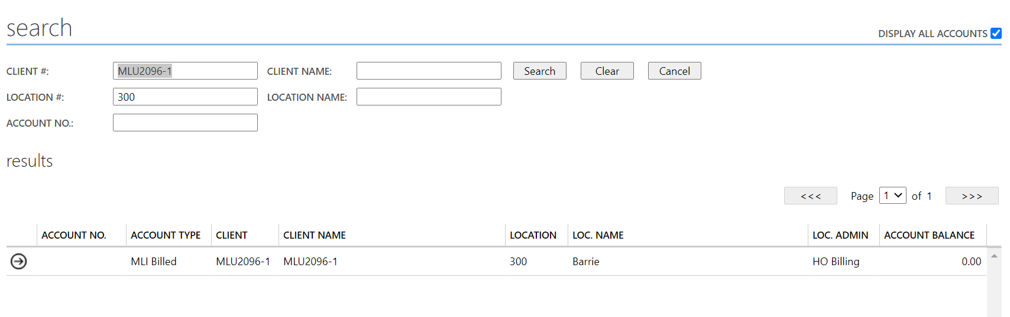
MLU-845 | 2593 | Admin GUI | [CDTASME-2593] Fixes required to the TR and the PAD screens | (2020-12-14)  The PACFlg in the audit trail is due to missing metadata to support the display. In this release we have added new metadata (ControlConcept) in DB upgrade to associate PACFlg to the yes/no drop-list.  _____  (2020-11-30) Resolved droplist lookups for Transaction Register audit trail.
MLU-867 | 2597 | Accounting | [CDTASME-2597] ASO BAR and client billed is showing in the TC under account setup and should only show MLI billed | - Updated the UI to hide the selection icon for accounts that are not "MLI Billed".  - Removed the add account button (since MLU-859 automatically creates accounts from the search screens).  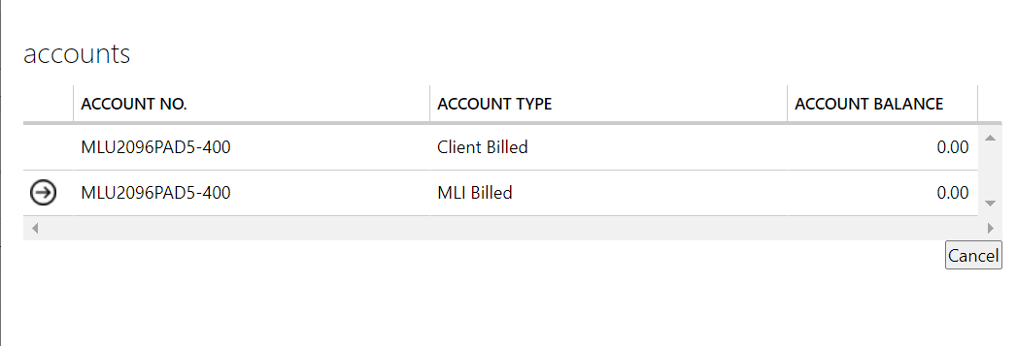
MLU-858 | 2598 | Accounting | [CDTASME-2598] ‘Withdraw Date’ not advances after PAD job run when One-Time payment amount coded for only Insured or ASO | A change is made such that the Withdraw Date is advanced even though there is no skip-next when one-time payment is used, as long as the Withdraw Date matches (or less than) the job date. The behaviour should be the same whether or not the one-time draw amount is insured or ASO or both.
MLU-857 | 2599 | Admin GUI | [CDTASME-2599] Contract number is not displaying when mouse hover the ‘Contract No’ field for HO ASOBAD billing line | Fixed the Contract No. tool-tip to be included for ASO BAD billing transactions.
MLU-862 | 2600 | Self-admin Billing | [CDTASME-2600] lock isn't being removed when jobs fail in job control Created | Currently if a failure occurs in process it is possible that the BillingGroup or ClientLocks will remain. Changes have been made to try and ensure that locks are removed. There are still occasions when a lock would remain for instance if the failure occurs because of a loss of connection to the database.
MLU-868 | 8727 | DB Upgrade | [170,1990] Use different batch sizes to back fill TransStatusCd | Version: 5.0  Scripts: 170, 1990  Issue:  The original script ran for 66 hours on Manulife's production database (copy). In running the script manually, they found that a batch size of 500000 was appropriate. With that batch size, each update statement ran in just under 10 seconds.  Change:  Use different batch sizes based on the number of rows in the table, in order to improve performance.
MLU-869 | 8727 | DB Upgrade | [270,280] Check the presence of constraint before dropping an index | Version: 5.0  Scripts: 270, 280  Problem:  The index files under BMAdminFeeAmt and BMBAdminFeeAmt were defined as PRIMARY KEY in Manulife's production database. So a simple DROP INDEX will not work.  Change:  Detect and drop the unique constraint before dropping the index.
MLU-870 | 8727 | DB Upgrade | [10840] Disable TransactnField data conversion | Version: 6.0  Script Id: 10840  Issue:  Manulife's TranactnField table has 1,624,637,897 rows. The first ALTER TABLE ALTER COLUMN command ran for 2 hours before it was killed.  Change:  Disable this script. The script will be run manually outside of the DB Upgrade.
MLU-871 | 8727 | DB Upgrade | [13413] Rename the new index to avoid collision with an existing index | Version: 6.3  Script Id: 13413  Problem:  This script adds a new index called XIF3ClassPlanLinkSet. Manulife already added an index (with different columns) with this name, causing the error in upgrade.  Change:  Manulife will rename index with a different naming convention before upgrade.  The index is generated from the data model tool that CWI uses (ERWIN). And it won't know that the name of the index has been modified manually in one instance. So in the future if it is modified again such as adding another column, for example, the change won't reach Manulife's database properly. Therefore, any custom indexes should not be named using the CWI naming convention.

